**Assignment 15**

1. **Create a Pivot table and show what the main export product is?**

* Scale is main export product

1. **Create a bar graph showing the amount spent for each product?**

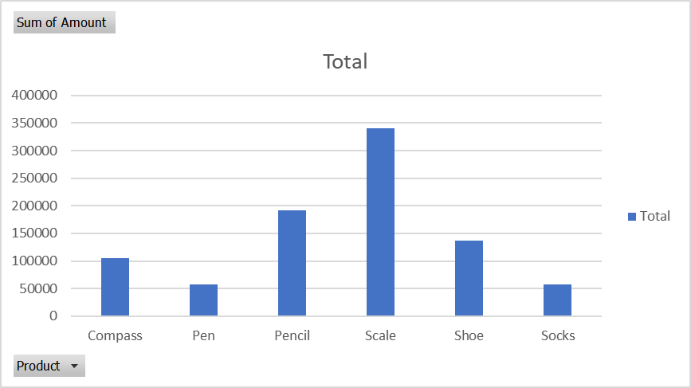

1. **Create a Pivot table to show The sales in each city**

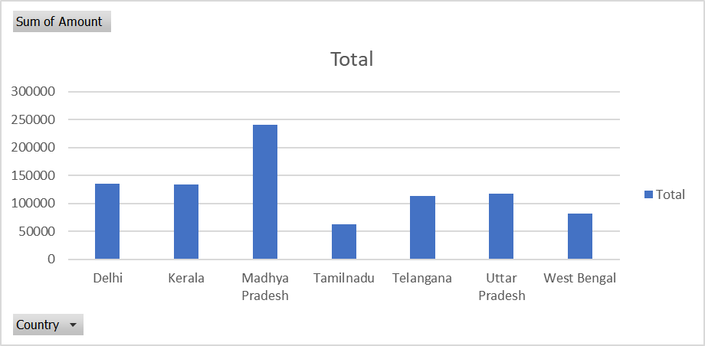

1. **Create a chart showing the amount spent for each product in each city**

